Bug_01:
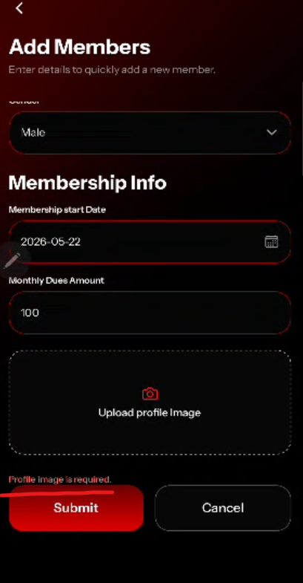
No validation error message on invalid email
Bug_02:
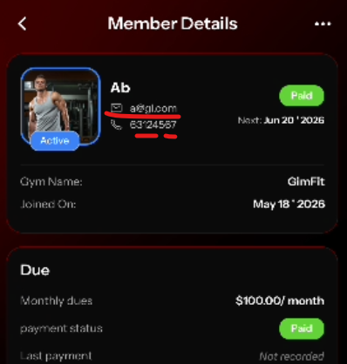
Member added while the email and phone number was incorrect/invalid

Bug_03:
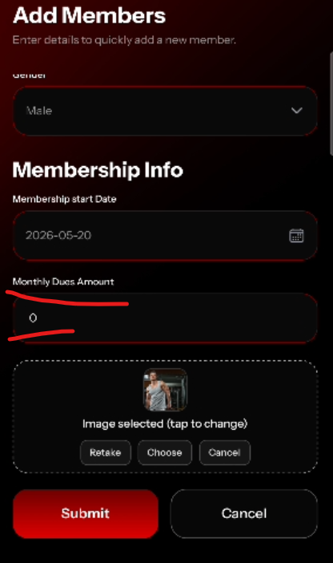
No proper Error Message shown when Monthly Dues Amount set to 0

Bug_04:
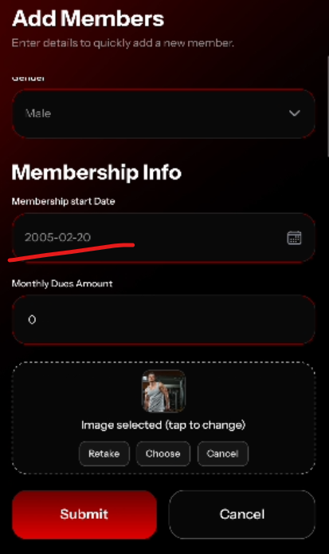
Membership start Date easily set to year 2005 without any error message.

Bug_05:
I delete a member while offline, but when back to online it inactive the member instead of deleting.
And when try to activate the member, it shows error.
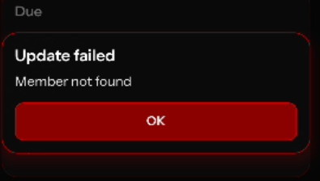

Bug_06:

When uploading an image while adding member, after selecting image there’s no next button or option

Bug_07:
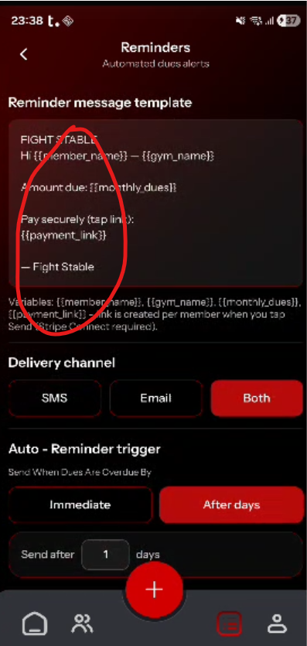

Bug_08:
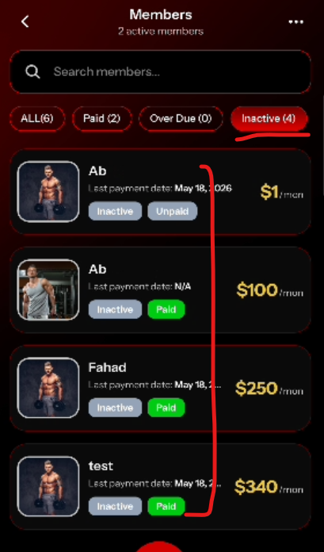

These 4 are deleted members but it still shows in inactive member

